PRACTICAL-4

- Write a C program where a parent process creates multiple child processes and synchronizes their completion using wait() and waitpid(). Compare the behavior of both functions.

Create a scenario where a child process becomes a zombie process. Investigate the process table and then modify the program to eliminate zombie processes using proper synchronization techniques.

CODE:-
#include <stdio.h>
#include <unistd.h>
#include <sys/types.h>
#include <sys/wait.h>
#include <stdlib.h>

int main()
{
int i;
pid_t pid;

for(i = 0; i < 3; i++)
{
pid = fork();

if(pid == 0)
{
printf("Child %d: PID = %d, PPID = %d\n",
i + 1, getpid(), getppid());

sleep(2 + i);

printf("Child %d finished.\n", i + 1);
exit(0);
}
}

printf("\nParent PID = %d\n", getpid());

// wait() waits for any child
printf("\nUsing wait():\n");
wait(NULL);

// waitpid() waits for specific children
printf("Using waitpid():\n");
while(waitpid(-1, NULL, 0) > 0);

printf("All child processes completed.\n");

return 0;
}

OUTPUT:-

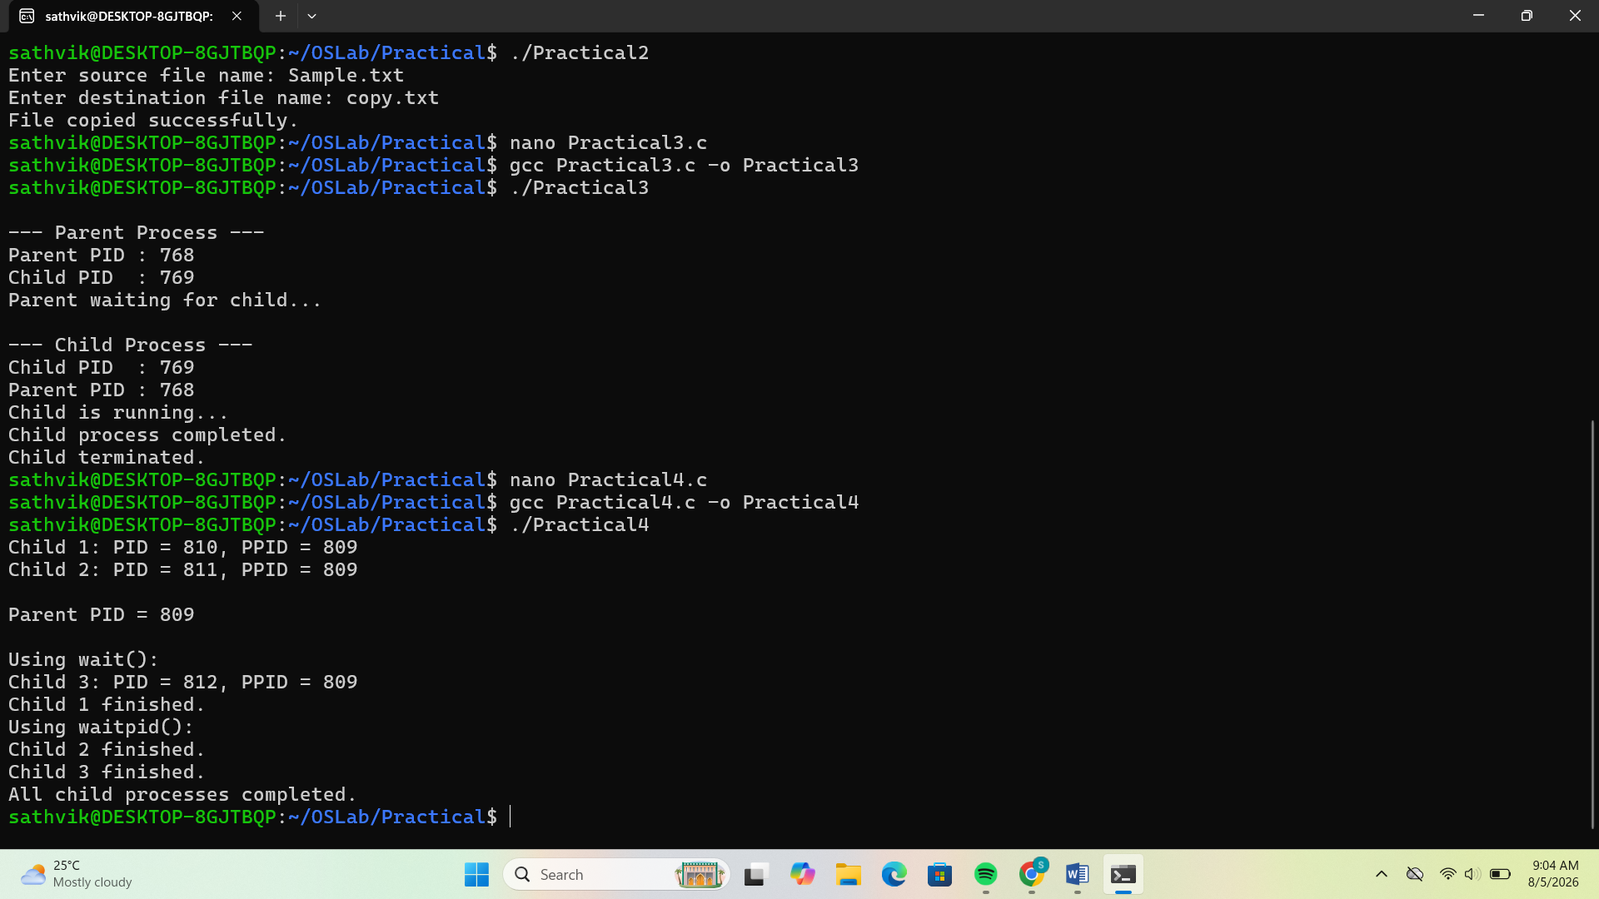

PART B:-

#include <stdio.h>
#include <unistd.h>
#include <stdlib.h>

int main()
{
pid_t pid = fork();

if(pid == 0)
{
printf("Child Process (PID = %d) exiting...\n", getpid());
exit(0);
}
else
{
printf("Parent Process (PID = %d) sleeping...\n", getpid());

sleep(20);

printf("Parent exiting.\n");
}

return 0;
}

